1)
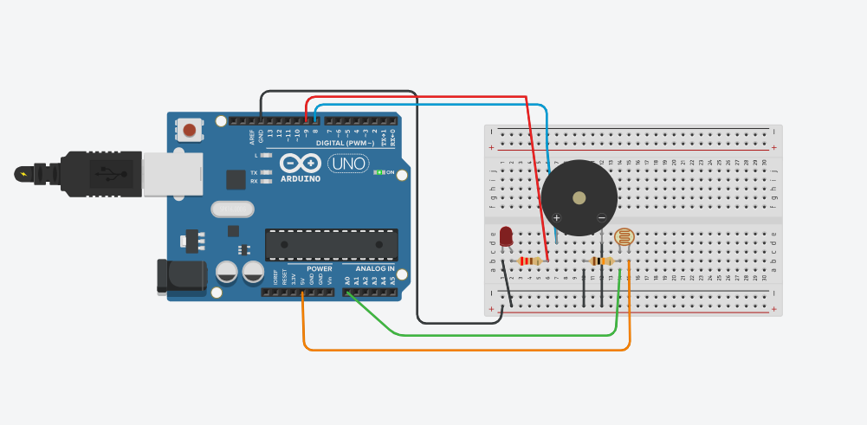
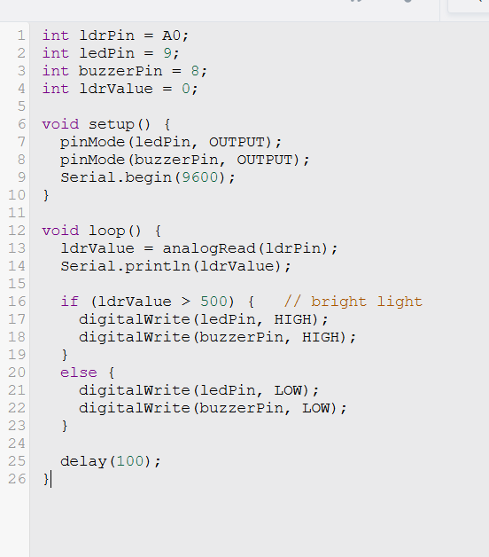

2)
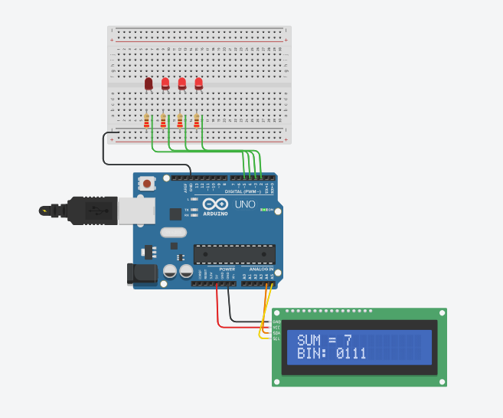
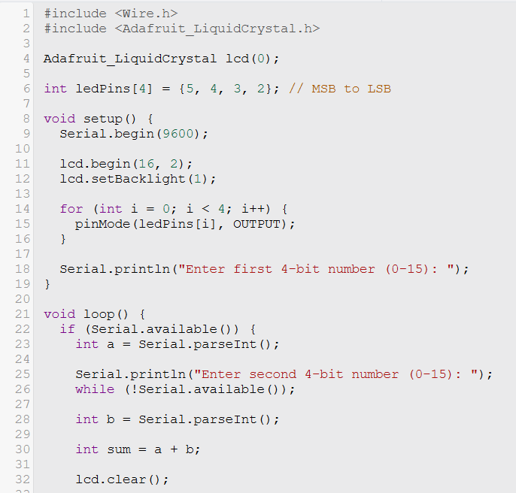
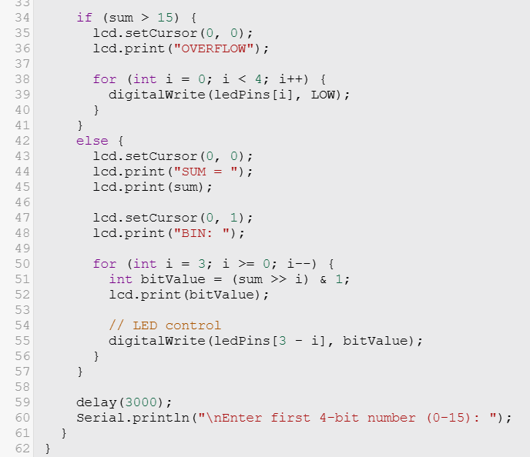

The output is shown by the LCD screen and the 4 leds which shows the binary representation of the sum of the two numbers. The sum must be a 4-bit number (till 15), otherwise the LCD display shows ‘OVERFLOW’. If the sum is indeed a 4bit number, the display shows both the decimal and binary representation for the sum, and using the ‘for’ loop in the code, the code checks each digit in the 4bit binary representation. If a digit of the binary number is 1, the led glows and if it is 0, the led doesn’t glow.

